**MID - SEMESTER PRACTICAL EXAM**

Register Number: 1740256

**Date:** 04/09/2017

**Question 1**

For a data set in Excel containing 25 values with the following information.

1. Employee id
2. Employee Name
3. Age as on 31st August.
4. Qualification (12th pass, U.G, P.G, Other)
5. Number of years of experience
6. Designation (A, B, C, D, E)
7. Male/Female.
8. Date of Joining the company.

**Aim** - To form a data set with the observations mentioned above.

**Procedure –**

1. Open a new MS excel sheet.
2. Enter the data in the excel sheet according to the guidelines given above.
3. Click on File, save as and save the document where you want to save it.
4. Close the tab.

**Calculations –**

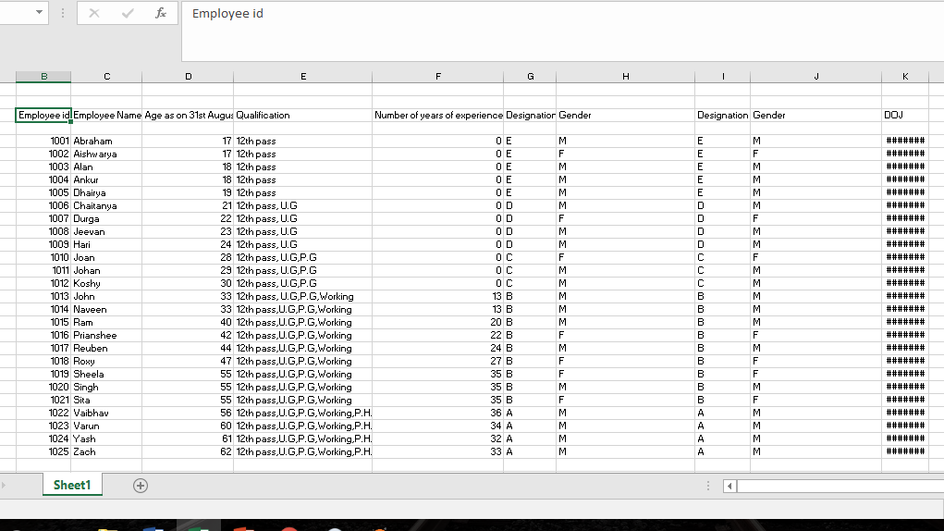

**Calculations –**

The picture contains 25 names with their respective qualifications.

**Aim** - To sort the given data according to their ages.

**Procedure –**

1. Select the column ‘ages’ in the excel sheet.
2. Click on sort and filter button.
3. A menu will drop down and click on smallest to largest.
4. The ages are then sorted.

**Calculations–**

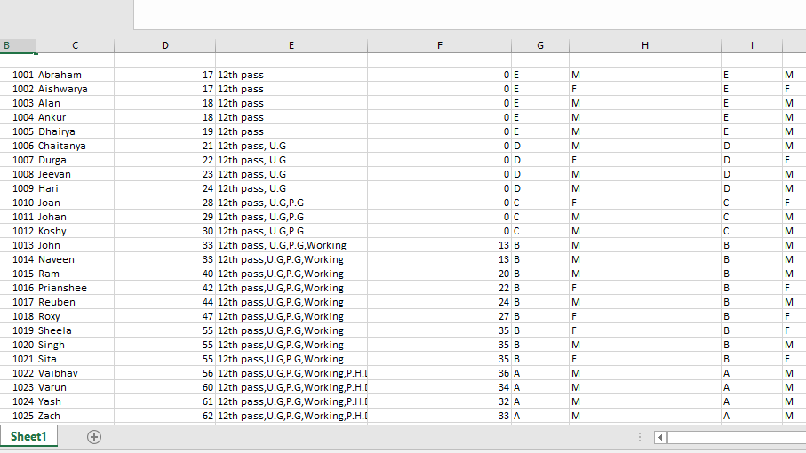

**Calculations –**

The picture contains 25 names with their respective qualifications.

**Aim** - To colour the data (25 names) for each qualification.

**Procedure –**

1. Open the MS Excel sheet which as the data.
2. Select the particular row you want to colour
3. Click on fill colour and choose the particular colour you want the row to be.
4. Click on save and then close the tab.

**Calculations –**

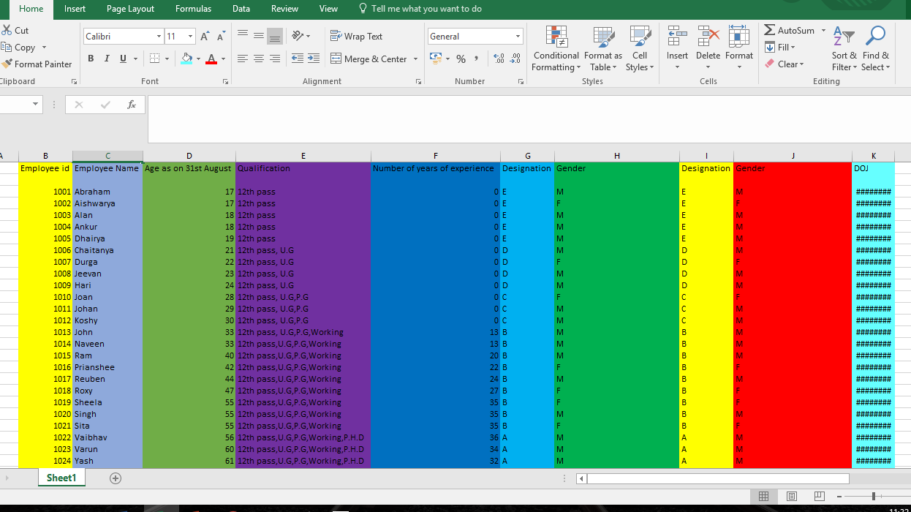

**Conclusions –**

The picture shows the different colours that each qualification has.

**Aim** – To represent the data with a diagram based on percentage basis.

**Procedure –**

1. Open the MS Excel sheet which has the 25 names.
2. Select the entire data.
3. Click on insert and go to recommended charts.
4. Choose all charts and selected 100% stacked column.
5. The graph in percentage will appear on the excel sheet.

**Calculations –**

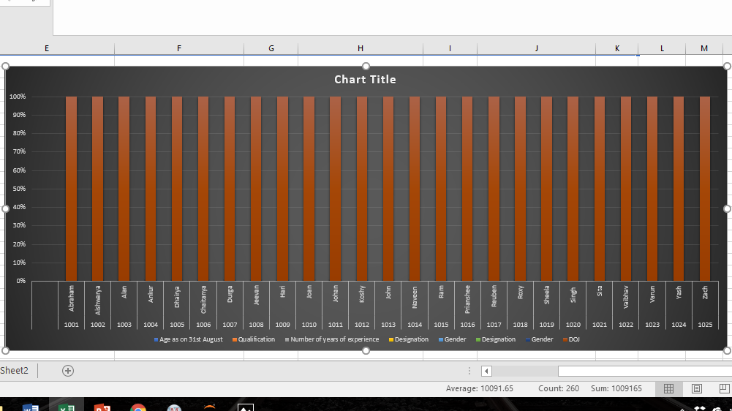

**Conclusions –**

The picture shows a percentage based diagram of the data.

**Aim** – To create a pivot table for the employee id and gender from the excel sheet.

**Procedure –**

1. Select all of the data from the excel sheet.
2. Click on Insert and then Pivot table.
3. Choose the particular column, new worksheet.
4. Drag the column to rows and then values.
5. Go to value field settings and click on count.
6. The pivot table appears on a new excel sheet.

**Calculations –**

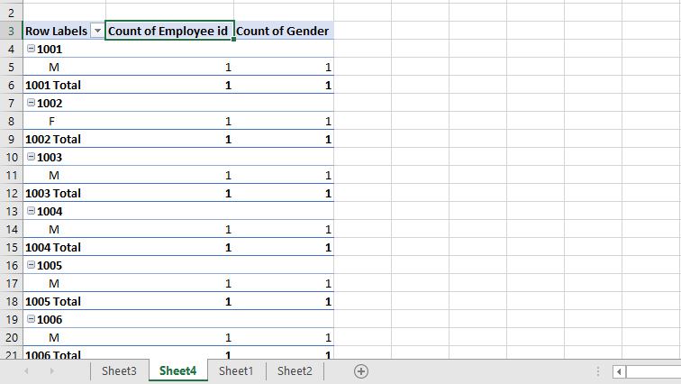

**Conclusions –**

The picture shows a pivot table of the data in the excel sheet.